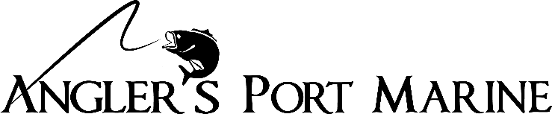
2021 Official Tournament Finish Affidavit

This document must be postmarked within 30 days after the conclusion of the qualifying tournament date.

I, __________________________ hereby attest that I finished in 1st place in the following qualifying tournament, ___________________________________________________ (name and date) which had ____ (# of) boats and was held in _________________________(city and state). Please provide website of the tournament as well.

Signature of Angler __________________________________ Date of event ______________________
Name of Tournament Director ____________________________ Phone # _______________________
Boat HIN _________________________________________

By submitting this form along with a current W-9 for payment in the Port Payout Program of Angler’s Port Marine in Warsaw, MO, I further acknowledge that I have met all the guidelines as required per the official rules posted on www.anglersportmarine.com website. I also certify that I won while fishing on my Angler’s Port Marine boat during the competition.
------------------------------------------------------------------------------------------------------------------------------------------
Name: ___________________________________________
Address: ___________________________________________
City: ___________________________________ State ___________________Zip_____________
Phone number ____________________________email address __________________________

Return completed documents to: Angler’s Port Marine
Attn Don Schlesselman
13979 Hwy 7
Warsaw, MO 65355

